**Name: Noman Siddique**

**Roll no. P19-1664**

**Computer Network Lab (A)**

**Homework 3**

**- Setting Router Modes on 2600 Series Routers**

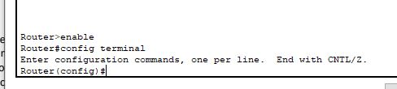

- **Changing Hostname of the Router**



**- Configuring Date and Time on the Router (Clock Set Command)**

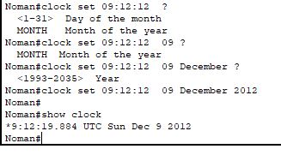

**- Setting a banner on the Router**

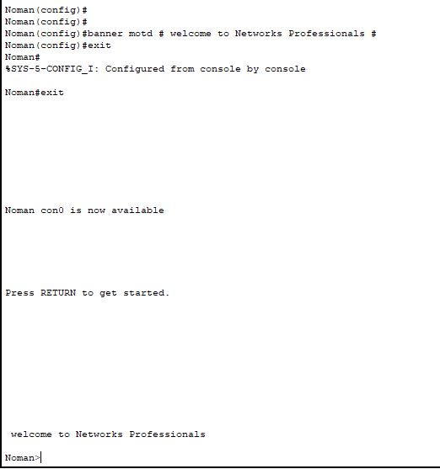

**- Displaying the Router’s Running-Configuration and Start-Up Configuration**

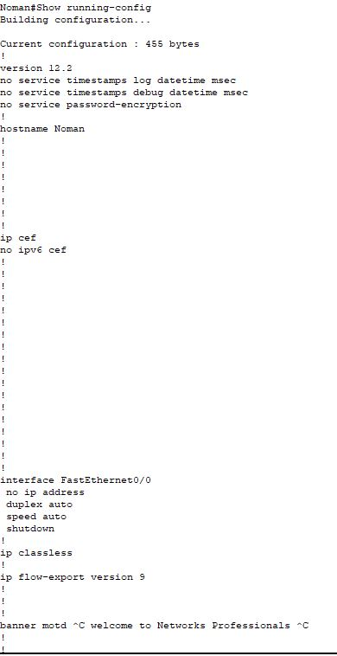

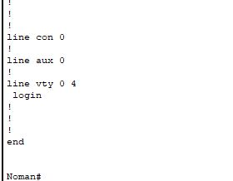

**- Enable Password and Enable Secret Password with the Encryption Techniques/Levels**

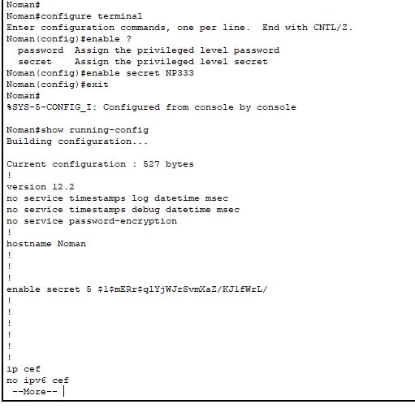

**- Line Console Password Implementation on CISCO 2600 Series Router**

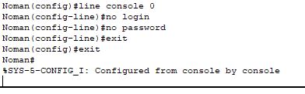

**- What is Telnet? How to Telnet? + Line VTY/Telnet Password**

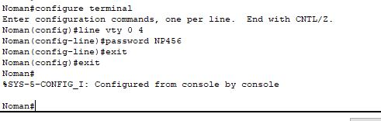

**- Usage of Router with different topology.**

Network topology is the description of the arrangement of nodes (e.g. networking switches and routers) and connections in a network, often represented as a graph.

A logical network topology is a conceptual representation of how devices operate at particular layers of abstraction. A physical topology details how devices are physically connected.

**Types of network topology**

**Bus Topology** Simple layout and cheap but vulnerable to failure and only suitable for low traffic volumes. Not used for office networks today, but can still be found within some consumer products.

**Ring Topology** Easy to manage and with a low risk of collision but reliant on all nodes being powered up and in full working order. Rarely used today.

**Star Topology** All devices are connected to a central switch, which makes it easy to add new nodes without rebooting all currently connected devices. This topology makes efficient use of cable and is easy to administer. On the other hand, the health of the switch is vital. This topology requires monitoring and maintenance. However, it is a commonly encountered topology.

**Tree Topology** A hierarchical layout that links together groups of nodes. Creates parent-child dependencies between root nodes and regular nodes. This layout can be vulnerable to failure if a root node has a problem. This topology is complicated and difficult to manage and it uses a lot of cable.

**Mesh Topology** Each node is connected to every other mode with a direct link. This topology creates a very reliable network, but requires a large amount of cable and is difficult to administer. Wifi networks make this topology more feasible.

**Hybrid Topology** Combines two or more of the standard topologies. This can be a good solution to create quickly link together different existing networks into a unified system. Don’t confuse the term “hybrid network topology” with “hybrid system” – a term that is applied to the combination of onsite and cloud resources.